- Introduction
  - Overview of Watermarking:
The rapid proliferation of multimedia over internet demands sophisticated technique for secure and efficient access to information. There is a growing need to discourage unauthorised duplication and use of digital data. With the advent of digital video, issues of copyright protection have become more important, since the duplication of digital video signals does not result in an inherent decrease in quality normally suffered by analog video. Steganography, data hiding, data embedding and watermarking are techniques used for the invisible embedding of information in the host data, with the intent information stored/transmitted together with the host data, the transmitted host data retains the secret information. The main difference between steganography and watermarking is that steganographic methods rely on the fact that covert communication is a point to point communication between trusting parties alone and that is unknown to third parties. Thus, steganographic methods are typically not designed to be robust against attempted attacks. In watermarking methods the existence of the embedded information is unknown to unauthorised parties who have access to the data, and can attempt unlawful attacks.

What is Digital Watermarking?

Digital watermarking is the process of embedding information into a digital signal in a way that is difficult to remove. The signal may be audio, pictures or video, for example. If the signal is copied, then the information is also carried in the copy. A signal may carry several different watermarks at the same time.

In visible watermarking, the information is visible in the picture or video. Typically, the information is text or a logo which identifies the owner of the media. The image on the right has a visible watermark. When a television broadcaster adds its logo to the corner of transmitted video, this is also a visible watermark.

In invisible watermarking, information is added as digital data to audio, picture or video, but it cannot be perceived as such (although it may be possible to detect that some amount of information is hidden). The watermark may be intended for widespread use and is thus made easy to retrieve or it may be a form of Stenography, where a party communicates a secret message embedded in the digital signal. In either case, as in visible watermarking, the objective is to attach ownership or other descriptive information to the signal in a way that is difficult to remove. It is also possible to use hidden embedded information as a means of covert communication between individuals.

  - Video Watermarking:

Digital watermarking for still images has been extensively studied. Today however, growing popularity of video based applications such as Internet multimedia, wireless videos, personal video recorders, video-on-demand, set-top box, videophone and videoconferencing has increased the demand for a secure distribution of videos. Apparently any image watermarking technique can be extended to watermarking videos, but in reality video watermarking techniques need to meet other challenges than that in image watermarking schemes. Some of the video characteristics that impact watermarking include:

- High correlation between successive frames. If independent watermarks are embedded on each frame, an attacker could perform frame averaging to remove significant portions of the embedded watermark.

- Some applications like broadcast monitoring require real time processing and therefore should have low complexity.

- The unbalance between the motion and motionless regions.

  - Properties of Video Watermark:

For digital watermarking of video, different characteristics of the watermarking process as well as the watermark are desirable:

  - Invisibility: The digital watermark embedded into the video data should be invisible to human observer.

  - Robustness: It should be impossible to manipulate the watermark by intentional or unintentional operations on the uncompressed or compressed video, at the same time, degrading the perceived quality of the digital video significantly thereby reducing its commercial value. Operations like addition of signals, cropping, lossy compression, frame dropping.

  - Fidelity: A watermark is said to have high fidelity if the degradation it causes is very difficult for a viewer to perceive. However, it only needs to be imperceptible at the time that the media is viewed. If we are certain that the media will be seriously degraded due to other means such as transmission before being viewed, we can rely on that degradation to help mask the watermark.

  - Computational Cost: Different applications require embedders and detectors to work at different speeds. In broadcast monitoring, both embedders and detectors must work in real time so they need to be fairly fast and should have low computational complexity. On the other hand, a detector for proof of ownership will be valuable even if it takes days to find a watermark.

  - Interoperability: Even though many applications call for watermarking in compressed videos, it would be a desirable property if uncompressed video could compatibly be watermarked without having to encode it first. Also, the watermark should sustain the compression and decompression operations.

- Literature Survey

The earliest scheme for image authentication was proposed by Walton that uses a key dependent pseudo-random walk on the image. In this Scheme, The check-sum is obtained by summing the numbers determined by the seven most significant bits (MSBs) and taking a remainder operation with a large integer N. The computed check-sum is then inserted in a binary form in the LSBs of the selected pixels. The method is very fast and on average modifies only half of the pixels by one gray level. The check-sum approach provides a very high probability of tamper detection, but cannot distinguish between an innocent adjustment of brightness and replacing a person’s face.

Phen et al [1] & Jagdish et al [2] proposed hierarchical based scheme in which intensity mean of blocks are embedded into randomly chosen block LSBs for authentication and recovery but for gray scale image authentication.

Fridrich [6]-[8] proposed schemes where in which image is divided into 8x8 blocks and each block is DCT (Discrete Cosine Transform) transformed. Specified number of the lowest frequency DCT coefficients are quantized using a given quantization table Q that corresponds to the 50% of JPEG quality. The encoded bits were then embedded into LSBs for authentication & recovery. Detailed survey on authentication schemes proposed by research community can be found in Liu, Z.D Que et al; in[6].

Wolfgang and Delp [9] extended van Schyndel’s work and improved the localization properties and robustness.

Van Schyndel et al. [10] modify the LSBs of the pixels by adding extended m-sequences to rows of pixels. The sequences are generated with a linear feedback shift register. For an N×N image, a sequence of length N is randomly shifted and added to the image rows. The phase of the sequence carries the watermark information. A simple cross-correlation is used to test for the presence of the watermark.

- Problem Statement

To create a GUI-based client application that helps the client watermark the owner’s video with any image or logo of his choice. The user should be able to embed an image or logo into the owners’ video successfully to create the watermarked video. The watermarked video created should be imperceptible, robust and unambiguous. The watermark logo or image can be extracted from the video using the same secret key that was used to watermark the video. The purpose of the watermarking application is to demonstrate authenticity of the owner of the original video.

- Requirement Analysis

  - Introduction:
    - Purpose:
In the past several years there has been an explosive growth in multimedia technology and its applications. This growth has escalated the necessity to build secure methods for legal distribution of the digital contents. As digital multimedia works (video, audio and images) become available for retransmission, reproduction and publishing over the Internet, need for protection against unauthorized copy and distribution is increased. Thus, there are rise in apprehensions over copyright protection of digital contents.
The main objective of this document is to illustrate the requirements of digital watermarking of videos. The document gives detailed description of functional and non-functional requirements. The purpose of this document is that the requirements in it should be utilized by software developer to implement the system.

    - Documentation Conventions:
The SRS document has been drafted according to IEEE format ^{[5]}.

    - Intended Audience:
The intended audiences for this document are the development team, testing team and end users such as, those who want to protect their data against improper use or want to authenticate the originator of the data.

    - Additional Information:
The algorithm accepts any image as logo but before processing converts it into binary image and embeds it. The algorithm requires only gray-scale videos. Both original and watermarked videos are required for the extraction process. The watermark is robust to geometric attacks. RC4 algorithm^{[4]} is used to generate pseudo-random numbers to encrypt the watermark.

    - Contact Information:

NAME | CLASS | CONTACT NO. | EMAIL ID
Rishita Vaghela | BE5 - 47 | 9664201087 | rishitavaghela@yahoo.in
Jruvika Bhimani | BE5 - 02 | 9892476011 | jruvika.bhimani@yahoo.com
Neha Jangale | BE5 - 20 | 9773149411 | neha.jangale@gmail.com

    - References:
- IEEE Recommended practice for Software Requirement Specification.^{[5]}
- Roger Pressman, Software Engineering: A Practitioners Approach,
(6th Edition), McGraw Hill, 1997.

  - Overall Description:

The application allows the client to select the video to be watermarked and the image to be used as the watermark. Using a secret key, the client can watermark the video and authenticate it. The watermarked video should have the least possible change in quality and the watermark should remain invisible. If the video contains a hidden message in the watermark, the end-user can retrieve the watermark image by using the same secret key to extract the original image.

    - Product Perspective:^{[1]}
In order to meet the requirements of invisibility and robustness, the algorithm adaptively modifies the intensities of the host frames pixels, in such a manner that it is unnoticeable to human eyes. The proposed algorithm divides the host frame into a predefined number of blocks; it also modifies the intensities of the pixels depending on the contents of the blocks. For security requirements, private keys have also been used in this algorithm. In this section, the overview of proposed watermarking scheme is shown in Fig (1). The scheme is composed of three main components:

- Watermark Modulation
- Watermark Embedding
- Watermark Extraction

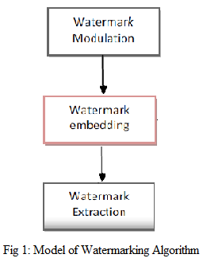

- Watermark Modulation :
The watermark L= [11, 12,...,1N] with li Є {0, 1}, is a bit sequence of length N, which may be a meaningful image, like a logo of images of an owner. The watermark is modulated by a bit-wise logical XOR operation, that contains a pseudo-random bit sequence s = [s1, s2, …, Sn] with Si Є {0,1} which is than multiplied by another pseudo-number sequence (0,1) to provide the modulated watermark sequence
W = [w1, w2, …, wN], as shown in Fig (2).
The seed values of the two pseudo-random number generators are regarded as the two private keys for the proposed algorithm.
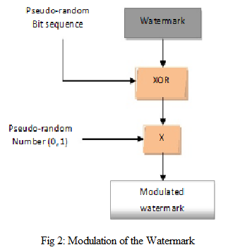

- Watermark Embedding Process:

The modulated watermark bit`s are inserted into the host frames blocks, depending on the contrast of the block. Before the embedding process the host frame is decomposed into n×n blocks and the value of n is found as follows:
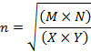
Where M, N and X, Y represent the dimensions of the host image and the watermark respectively.
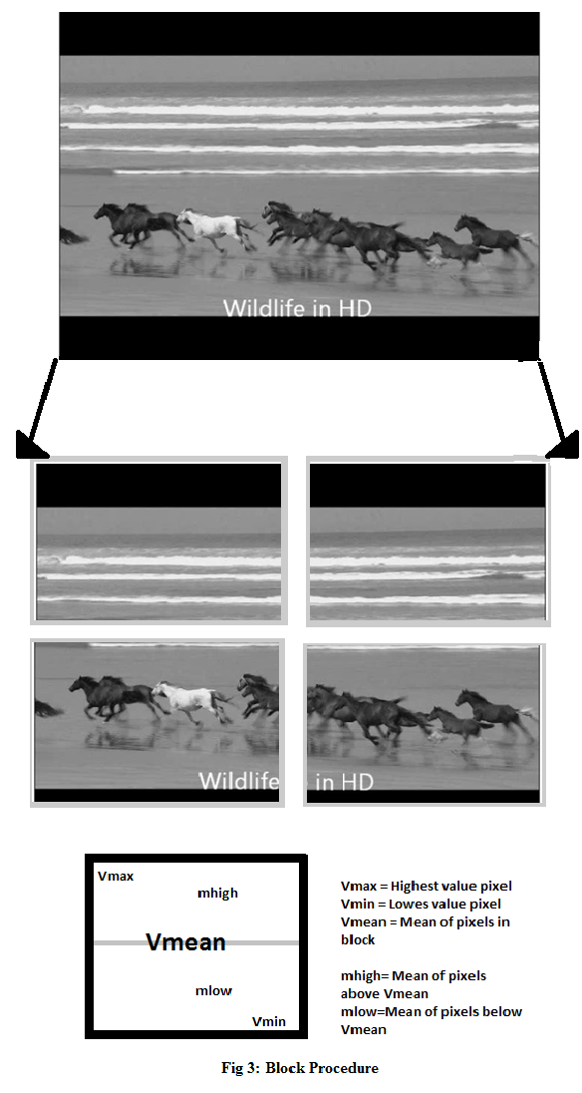
The process of embedding in each block is carried out according to the following procedure:
- Calculate the mean, maximum and minimum values of the block.
- Find the values in the block that are above and below the mean value.
- Calculate the mean values of those below the blocks mean value and the mean values of those above it.
- Calculate the new pixels values V` according to the following :
Inserted bit 0
If V < mlow then
V’ = Vmin
ElseIf Vmean < V < mhigh then
V’ = Vmean
Else
V’ = V - a

Inserted bit > 0
If V < mhigh then
V’ = Vmax
Else If mlow < V < Vmean then
V’ = Vmean
Else
V’ = V + a

Where V is the original intensity, Vmean, Vmax, Vmin represent mean, maximum and minimum values of the blocks respectively. Whereas mlow and mhigh represent the mean values of the pixels above and below the mean value of the block respectively.

- Finally the original frame is replaced with the resulting watermarked frame.

- Watermark Extraction:

According to the embedding procedure, the sum of pixels in the watermarked block is larger than that of the original frame if the embedded bit is 1. On the other hand, if the embedded bit is 0, than the sum of pixels in the watermarked block is smaller than that of the original frame. Hence, the original and the watermarked frames are used in the extraction process. Both of the frames are divided into the same blocks, which are used for the embedding process.
The sum of pixels for each corresponding block is computed, and if the sum of the original frame block pixels is greater than that of the watermarked frame, the extracted bit is considered to be 0, otherwise it is considered to be 1.
The extracted bits are then processed by XOR, with the same pseudo-random sequence used for embedding to produce the extracted watermark.

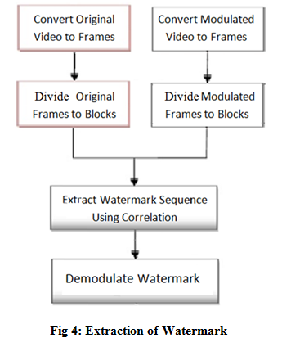

    - Product Function:
The system allows the following functions to the client accessing the application :

Embedding:
- Select the video to be watermarked and the logo or binary image to be used as the watermark image.
- Enter a secret pass key to perform modulation to the watermark image.
- Display the modulated watermark image.
- Convert video into frames.
- Embed the modulated watermark into these frames.
- Convert modulated frames back to video.
- Display the watermarked video sequence.

Extraction:
- Take the original video and modulated video.
- Convert both video sequences to frames.
- Extract watermark using correlation between original frames and watermarked frames.
- Display the extracted watermark image.

    - User Classes And Characteristics:
The product can be used by different classes of users. The watermarked video can be used for personal transactions within or outside a company or home. These watermarked videos can also be released worldwide.

- Educational level: No constraints on qualifications, but the user should be comfortable with a computer.

- Technical Expertise: User should be comfortable using general purpose applications.

    - Operating Environment:
The operating environment required for this application to implement successfully is:
- Windows XP or later versions.
- CPU 1.8 GHz.RAM 1GB.
- Hard Disk space atleast 5 GB free.
- MATLAB installed on machine.

    - User Environment:
Since the application is stand-alone it does not require any specific user environment except for operating environment.

    - Design And Implementation Constraints:
The system accepts only those videos that are stored in the system. It does not watermark real time videos i.e. watermark the videos at the same time as it is recording.

    - Assumptions:
The receiver has original watermark logo, original video and watermarked video. The receiver has pass key to generate pseudo random numbers, hence providing authenticity of user.

  - External Interface Requirements:
    - Users Interfaces:
The basic graphical user interface will be available to the user for simple and faster understanding of the work environment. This GUI will consist of some standard tabs such as Browse, Submit, Reset, Cancel, Select from list etc.

    - Hardware Interfaces:
It is desirable that the system have these minimum requirements:
- Intel Core2Duo or AMD processors.
- Minimum 1GB RAM.
- Preferable processors with speed over 1.5 GHZ.
- 5 GB hard disk free space.

    - Software Interfaces:
- MATLAB 2009 or higher installed.

  - Other Non-functional Requirements:

    - Performance Requirements:
The algorithm implemented helps the user to watermark the videos and ensure the following parameters:

- Perceptibility: The video watermarked should be imperceptible, i.e. it should not be able to differentiate the original video from the watermarked video.

- Robustness: A digital watermark is called robust if it resists a designated class of transformations, for e.g. geometric attacks like flipping, rotating, scaling, shearing, cropping, translation etc.

- Ease of embedding and retrieval: The computation need for the selected algorithm should be minimum.
    - Safety Requirements:
The system may get crashed at any certain time due to virus or operating system failure because of overload of data.

    - Security Requirements:
Watermark information shall only be accessible to the authorized parties. Only authorized parties shall be able to alter the Watermark content. Encryption is used to prevent unauthorized access of the watermarked data.

    - Software Quality Attributes:
- User Friendly: The user interface will develop in such a way that even novice users can use it effectively.

- Portability: The application will be easily portable on any windows-based system with MATLAB installed. Also the system requires Java installed.

- Maintainability: The application will be designed in a maintainable manner. It will be easy to incorporate new requirements in the individual modules.

- Scalability: Additional features can be added by just using the current features with some modifications.

  - Other Requirements:

    - Terminology/Glossary/Definitions List:
- Digital Watermarking: Digital watermarking is the process of embedding information into a digital signal which may be used to verify its authenticity or the identity of its owners, in the same manner as paper bearing a watermark for visible identification. In digital watermarking, the signal may be audio, pictures, video or text.

- Frames: Frames are electronically coded still image in video technology.

- Pseudo Random Numbers: A set of values or elements that is statistically random, but are derived from a known starting point and is typically repeated over and over. Pseudo-random numbers provide necessary values for processes that require randomness, such as creating test signals or for synchronizing sending and receiving devices in a spread spectrum transmission. It is called "pseudo" random, because the algorithm can repeat the sequence, and the numbers are thus not entirely random.

- Authentication/Integrity: Authentication/Integrity verifies that content is genuine, from an authorized source and has not been altered.

- Copyright Communication: Copyright Communication identifies content owner and rights.

- Copy Protection: Copy Protection controls recording and playback of content.

- Encoder: An encoder is a device, software program, algorithm or person that converts information from one format or code to another, for the purposes of standardization, speed, secrecy, security, or saving space by shrinking size.

- Decoder: A decoder is a device which does the reverse operation of an encoder, undoing the encoding so that the original information can be retrieved.

- Steganography: Steganography is the art and science of writing hidden messages in such a way that no one, apart from the sender and intended recipient, suspects the existence of the message, a form of security through obscurity. The word “Steganography” is of Greek origin and means "concealed writing" from the Greek words “steganos” meaning "covered or protected", and “graphei” meaning "writing".
System Flow Chart

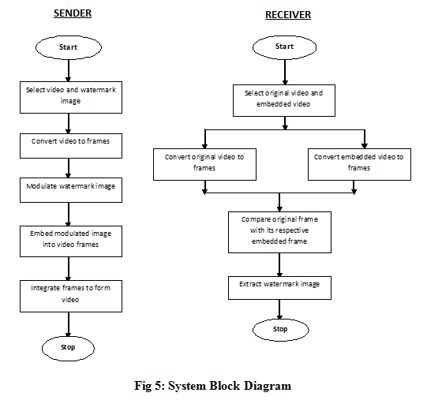

Data Flow Diagram
Sender:
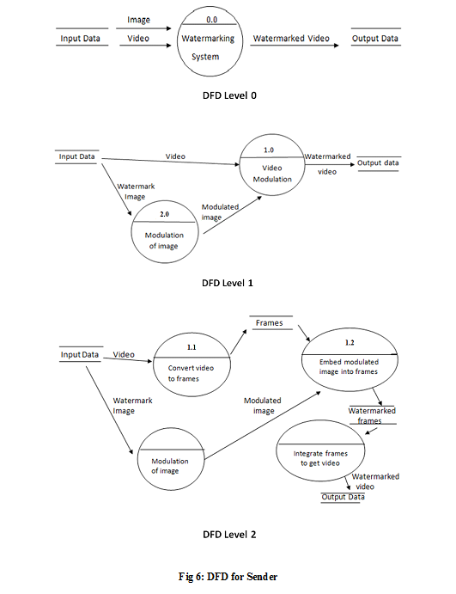

Receiver:
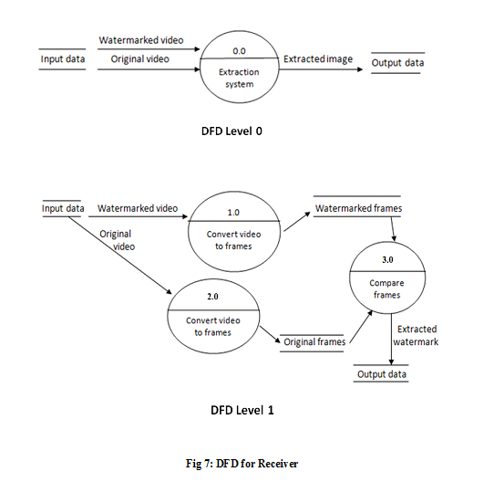

- Implementation Details

  - Module And Description:

Module 1: Watermark Embedding:
The process gives the output as the watermarked video. Initially the application accepts the host image i.e. logo and the original video. The process is divided into two main steps:
  - Watermark modulation
  - Embedding process

Watermark modulation:
The image values are XORed with pseudo random numbers. The pseudo random numbers are generated using RC4 algorithm^{[4]}. The XORed output is then multiplied with the random number (0, 1). The output obtained from this process is the modulated image in encrypted form.

Embedding process:
The original video is taken as the input and converted to frames. The image is embedded in each and every frame of the video. Each frame is then divided into blocks. The block size is obtained using the frame size and the image size. The modulated watermark bits are inserted into the host frames blocks, depending on the contrast of the block. The embedded bit is imperceptible to HVS (Human Visual System). After the modulation of every frame, it is again converted to video.

Module 2: Watermark Extraction:
The modulated video and the original video are taken as the input for the process. Both the videos are converted to frames. Each frame is divided into blocks of same size used for embedding process. Each block is compared with the respective block. If the modulated block summation is greater than the original block summation then the extracted bit is considered as ‘1’, else it is considered as ‘0’. The extracted bit matrix is then demodulated using the same pseudo random number generation. The output of the process is the original image.

Module 3: Video and Watermark Analysis:
As a measurement for the quality of a watermarked frame, the Peak Signal to Noise Ratio (PSNR) is used. PSNR of each and every frame is taken and the averaged value is analyzed.
Similarly to analyze the extracted image correlation factor NC is computed. If the value of NC > 0.5, the extracted image is said to be similar to the original image.

Module 4: Attacks:
The algorithm implemented is robust against various geometric attacks like cropping, scaling, rotation etc. we have performed the cropping attack. The user enters the percentage and the side that needs to be cropped. According to the user’s input the modulated frames are cropped. The cropped frames are again converted to video.

  - Snapshots:
    - Watermark Embedding:

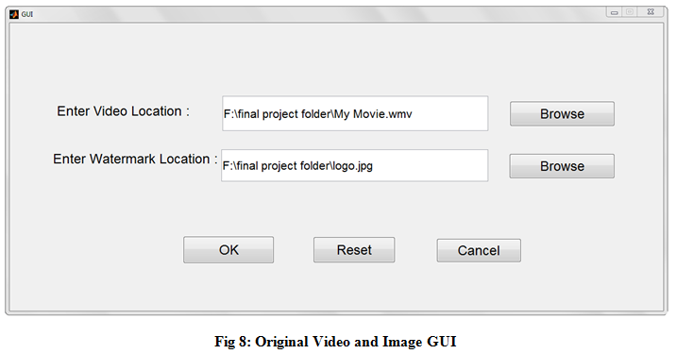

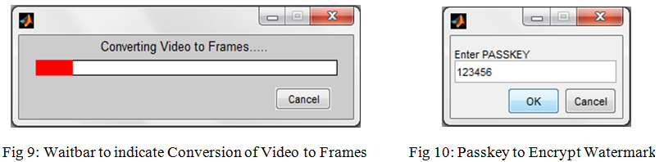

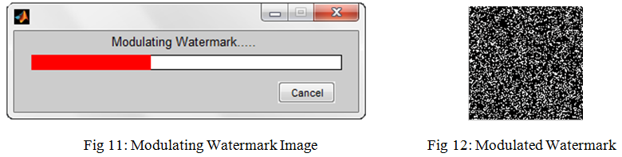
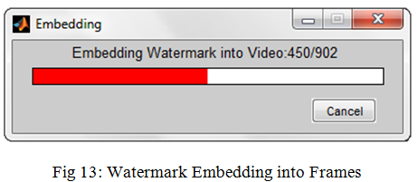

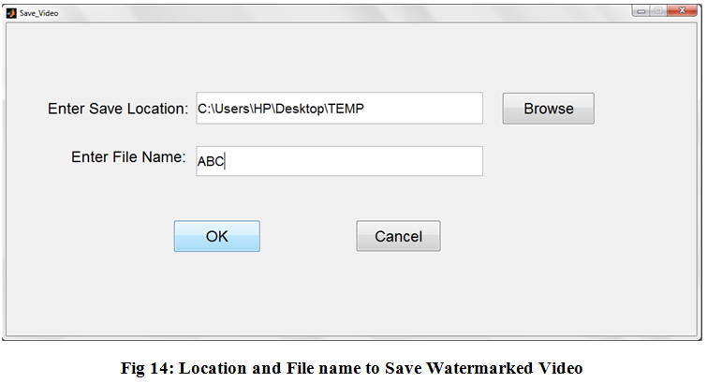

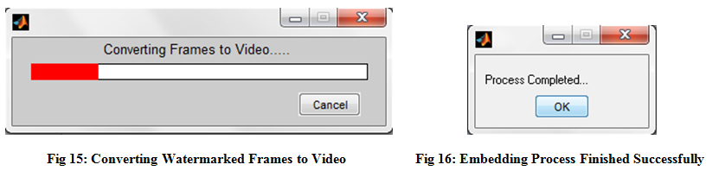
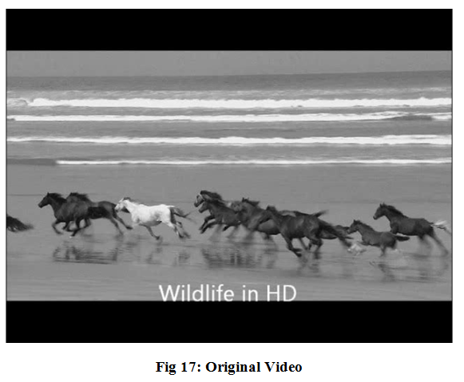
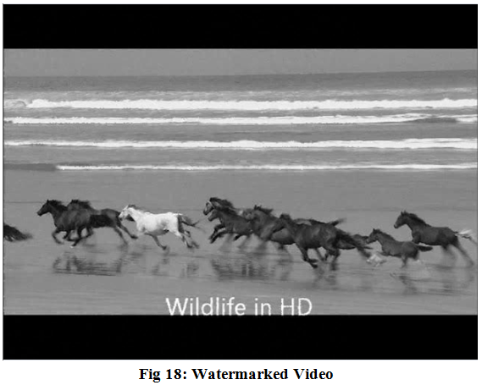
    - Watermark Extraction:
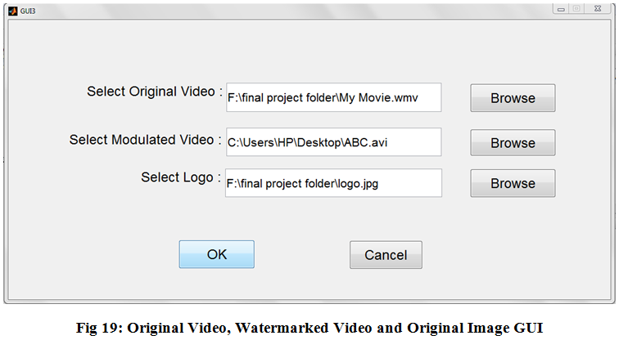

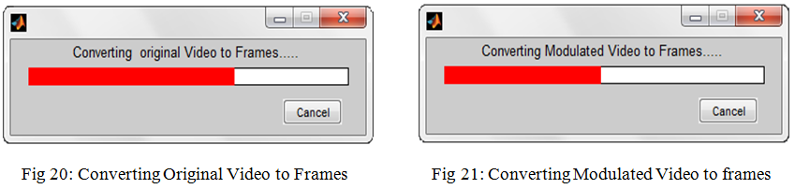
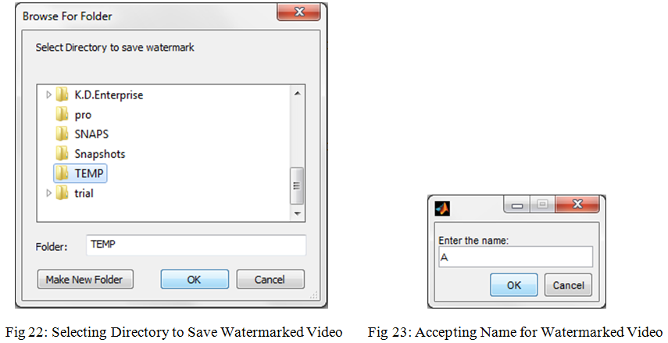

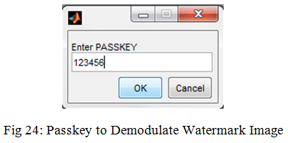

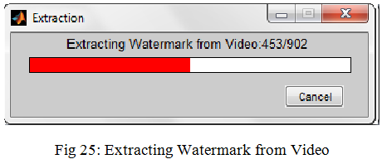
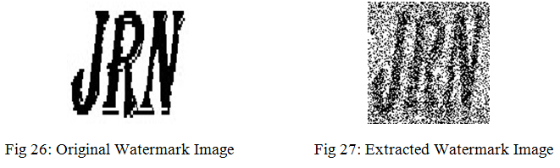

    - Analysis:

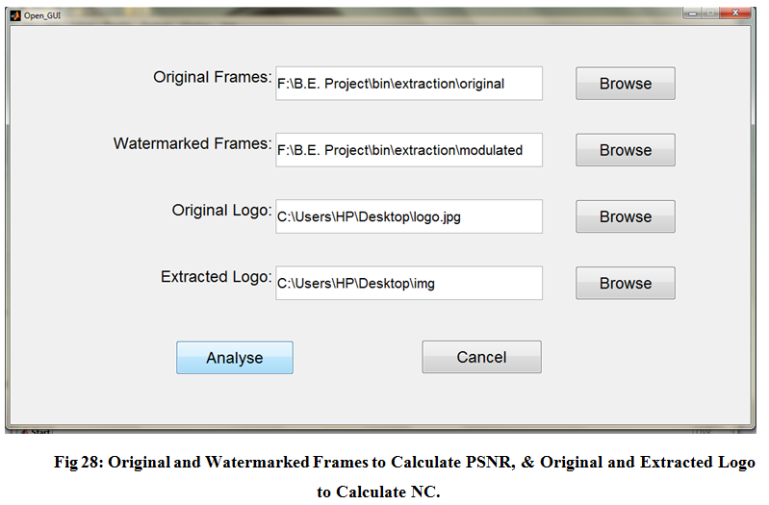
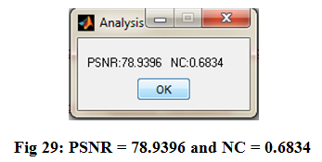

    - Attacks:
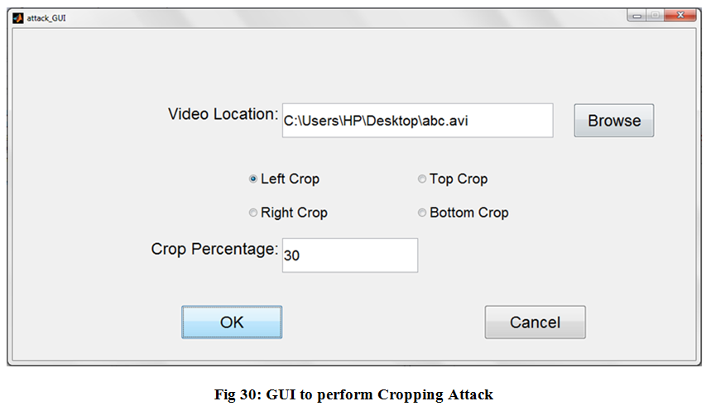
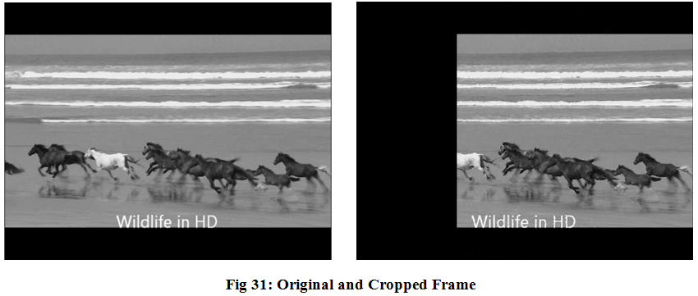
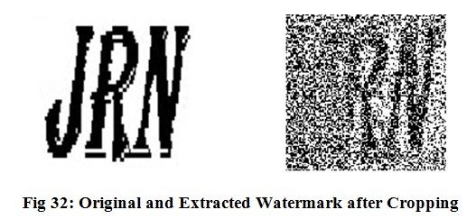
- Testing
Module 1 : Watermark Embedding

Test case ID | Objective | Steps / Description | Input | Expected Output | Actual Output | Result | Remark
EmW1 | Open GUI on MATLAB | Click on the run button OR type the GUI filename in MATLAB | Mouse Event/ Keyboard Event | GUI screen | GUI screen | GUI runs | Pass
EmW2 | Browse files to  select video and  watermark image | Click on Browse button on GUI | Mouse Event | Browsing window with all files and folders for selection | Browsing window with all files and folders for selection | User can browse through any folder for a stored video and image | Pass
EmW3 | Converting video to frames | Input video is converted into frames | Selected input video | A folder named “frames” is created with jpeg images of frames of video. | “frames” folder is created with the frames of the video in it | Frames of video | Pass
EmW4 | Watermark Modulation | Watermark image is modulated using entered passkey to get modulated watermark | Selected watermark image and entered passkey | A folder named “others” is created with the modulated watermarked stored in it | “others” folder is created with the modulated image stored in it | Modulated watermark image | Pass
EmW5 | Embedding watermark into video | Modulated watermark is embedded into frames of the video depending on the contrast of the frames | Modulated image and frames of video | A folder named “m_frames” is created with the embedded video frame s stored in it | “m_frames” folder is created with embedded video frames stored in it | Watermarked frames of video | Pass
EmW6 | Converting modulated frames to video | Modulated frames from m_frames folder are converted back to get the embedded video | Modulated frames from “m_frames” folder. | Modulated video is created | Modulated video is created | Modulated video | Pass

Module 2: Watermark Extraction

Test case ID | Objective | Steps / Description | Input | Expected Output | Actual Output | Result | Remark
ExW1 | Open GUI on MATLAB | Click on the run button OR type the GUI filename in MATLAB | Mouse Event/ Keyboard Event | Embedding GUI screen | Embedding GUI screen | Embedding GUI runs | Pass
ExW2 | Browse files to  select watermarked video, original video and watermark image | Click on Browse button on GUI | Mouse Event | Browsing window with all files and folders for selection | Browsing window with all files and folders for selection | User can browse through any folder for a stored video and image | Pass
ExW3 | Converting original video to frames | Original video is converted into frames | Selected original video | A folder named “frames” is created with jpeg image frames of video stored in it | “frames” folder is created with the frames of the video in it | Frames of original video | Pass
ExW4 | Converting watermarked video to frames | Watermarked video is converted into frames | Selected watermarked video | A folder named “m_frames” is created with jpeg image frames of video stored in it | “m_frames” folder is created with the frames of the video in it | Frames of watermarked video | Pass
ExW5 | Enter passkey for Extraction | The passkey entered from the receiver side should match the passkey entered for watermark modulation in the embedding process | Keyboard event | Entered passkey matches and extraction process begins | Entered passkey matches and extraction process begins | Extraction process begins | Pass
ExW6 | Extraction Process | Modulated frames and original frames are compared to extract embedded image | Modulated frames, original frames, watermark dimensions | Extracted watermark image is obtained | Extracted watermark image is obtained | Extracted watermark image | Pass
- Results And Analysis

As a measurement for the quality of a watermarked frame, the peak signal to noise ratio (PSNR) is used. PSNR is defined as:

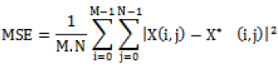

Where, X is the coefficients of the original video and X* are the coefficients of the watermarked video. M and N are the height and width of the frame respectively.

Experimental results show that the proposed algorithm is robust to attacks; the similarity between the original and extracted watermarks is measured using the correlation factor a “NC”, it may take between 0 and 1.

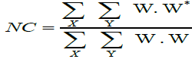

The similarity values vary in the interval [-1, 1]; a value well above 0 and close to 1 indicates that the extracted sequence matches the embedded sequence W. and therefore, we can conclude that the video has been watermarked with W.

Video | Watermark | PSNR | NC
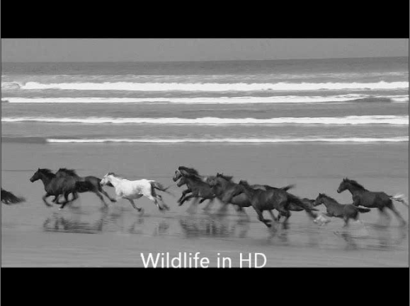 |  | 78.9396 | 0.67785
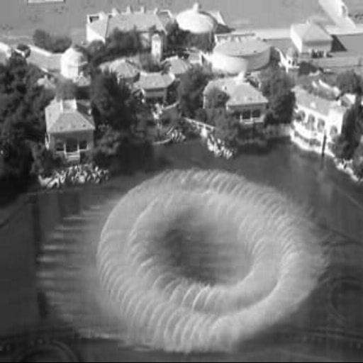 |  | 78.2508 | 0.73148

Video | Watermark |  | PSNR | NC
 |  | 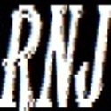 | 78.9396 | 0.6916
 |  |  | 78.2508 | 0.736

The results show that the NC value of the extracted watermark image and original image is better when there is less change in the background of the video. When the watermark image has more black components, the extracted watermark is of better quality.

After Attack:
Video | Watermark |  | PSNR | NC
 |  |  | 78.9396 | 0.67785
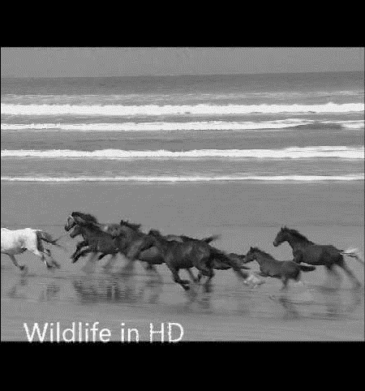 |  | 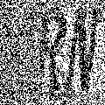 | 78.9396 | 0.60498

- Conclusion And Future Scope

In this project, we present a general coding-type framework that provides a useful and constructive tool in analysis and design of a video watermarking-based authentication system.
A robust video watermarking algorithm using spatial domain is proposed which embeds an image (logo) into host frames blocks, depending on the contrast of the block. The image embedded acts as an invisible watermark concealing its identity within the video. Thus by comparing the original video frames with the modulated frames, the watermark image can be extracted.
This method presents data hiding; thus the image remains concealed within the video. It helps verify the authenticity of the owner with the proof as the extracted watermark image. The confidentiality of the image is also maintained as the image can only be extracted using the sender’s secret passkey. The experimental results show that the embedded watermark has high PSNR and invisible. The watermark was successfully embedded and extracted.
For future work, scene detection can be used that can make the watermarked video robust against frame dropping and geometric attacks. The frame dropping can be prevented by adding watermark image into each segmented scene and increase its robustness.

References
[1] Sadik Ali. M. Al-Taweel1, Putra. Sumari, Saleh Ali K. Alomari, School of Computer Science, Universiti Sains Malaysia,11800 Penang, Malaysia “Robust Video Watermarking Algorithm Using Spatial Domain Against Geometric Attacks” (IJCSIS) International Journal of Computer Science and information Security, Vol. 8, No. 2, 2010.

[2] Phen Lan Lin, Chung-Kai Hsieh, Po-Whei Huang, “Hierarchical Digital Watermarking Method for Image Tamper Detection and Recovery”, Journal of Pattern Recognition, Elsevier, 2005.

[3] Jagdish C. Patra, Kah K. Ang and Ee-Luang Ang, “Hierarchical Multiple Image Watermarking for Image Authentication and Ownership Verification”, ICIP, 2004.

[4] William Stawlings, ”Cryptography and Network Security Principles and Practices, 3rd edition”, Pearson Publication, 2003.

[5] IEEE Recommended Practice for Software Requirement Specification-IEEE sts 830-1998.

[6] T.Liu and Z.D. Qiu, “The Survey of Digital Watermarking based Image Authentication Techniques”, 6th International Conference, pp. 1566-1559, 2002.

[7] J. Fridrich, “Methods for Tamper Detection in Digital Images”, Multimedia and Security Workshop at ACM Multimedia, Orlando, Florida, USA, Oct, 1999.

[8] J. Fridrich, “Image Watermarking for Tamper Detection”, Proc. ICIP’98, Chicago,
Oct 1998

[9] R. B. Wolfgang and E. J. Delp, “A Watermark for Digital Images”, Proc. IEEE Int. Conf. on Image Processing, vol. 3, pp. 219–222, 1996.

[10] R. G. van Schyndel, A. Z. Tirkel, and C. F Osborne, “A Digital Watermark”, Proc. of the IEEE Int. Conf. on Image Processing, vol. 2, pp. 86–90, Austin, Texas,1994.

